Lab 5

EGCP 381

By Levi Randall

Introduction

In this lab, we modified our Lab 3 processors to execute instructions in a pipeline. This is done by adding many registers that hold values, including ALU value holding registers, that could store values without needing the slow memory unit. Pipelined processors, can execute fasters much faster, by utilizing all pieces of hardware and reducing downtime of hardware, however, it comes with its own hazards which need to be appropriately addressed.

Procedure

To accomplish this, I modified the Datapath heavily and added two separate control files. I then added many registers on the Datapath and sent their enable signals to a control file. The ABCD register file works as a register that the ALU can call upon as memory. This allows numbers to be stored and then operated on without the need for a memory device.

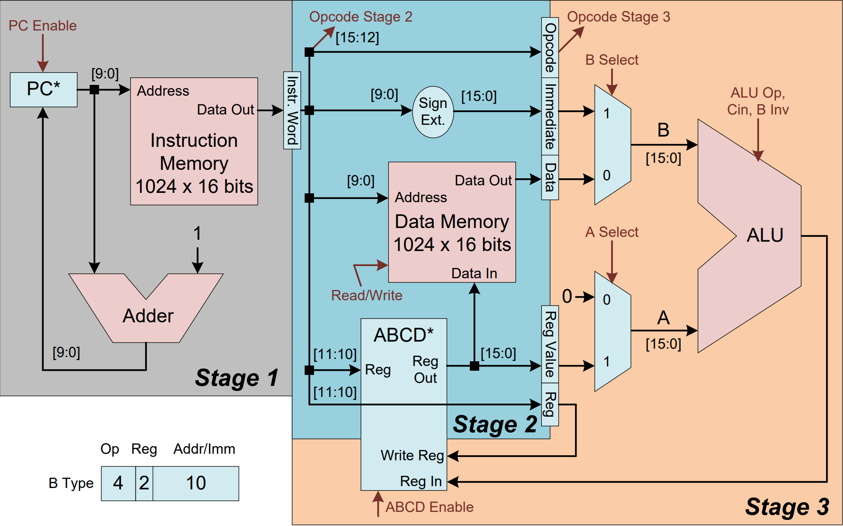

I then spent a considerable amount of time testing and debugging to create the desired results. I successfully created the desired results and found my design to work properly. All registers carry the correct information and the RAM memory contained the same values after being stored.

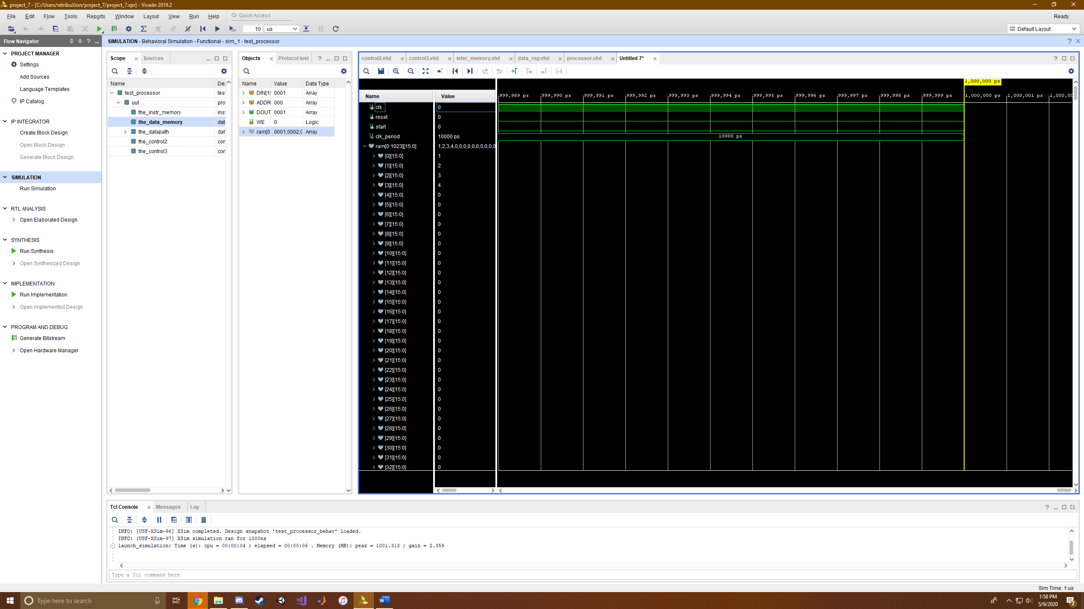

Waveform Showing RAM Values

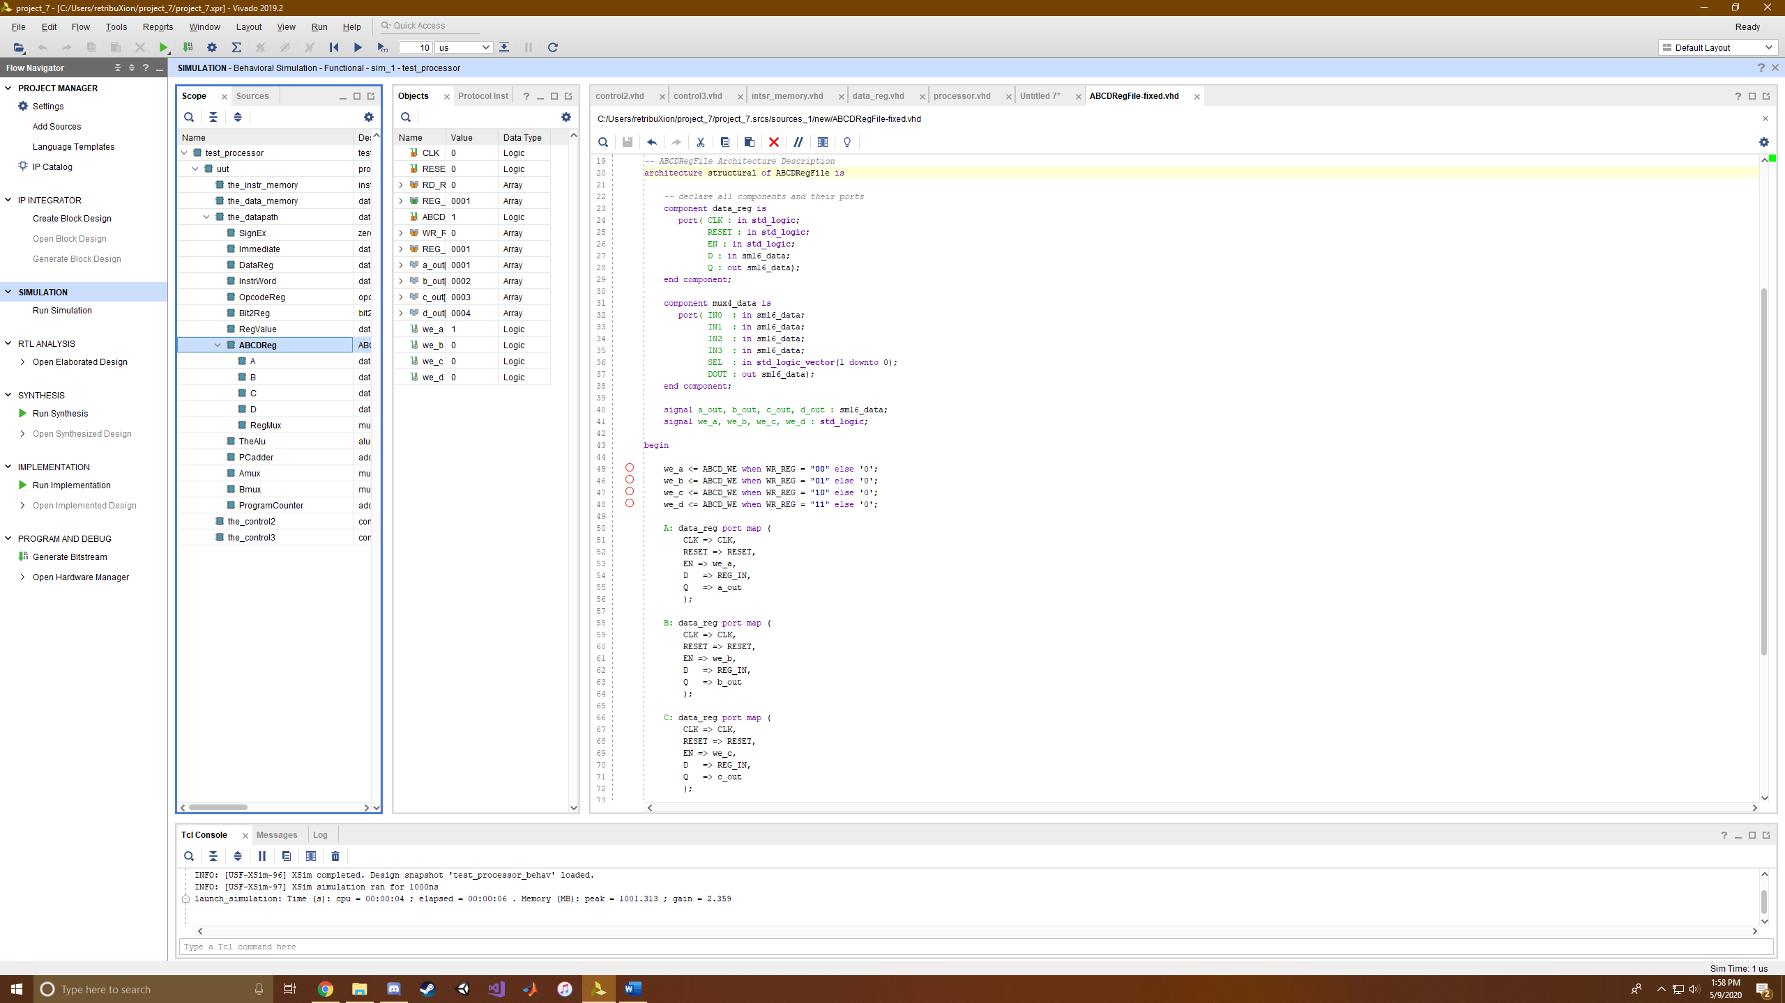

ABCD Registers Showing Reg Values

Hazards

Now to talk about Hazards. This pipeline has a problem with data hazards. An example of this is when a load and store operation are in that order. The load operation takes longer than the store value because it needs to place the value in the register and store does not. This means that the store could potentially change the value before it was loaded. To modify this, I may make the store instruction take the same number of cycles as the load so that store and load go off at the same time.

Also for control hazards, the pipeline circuit will have a potential issue if a branch is taken because the next instruction coming afterwards will be executed regardless of the branch decision. This at minimum needs a branch delay slot or could be solved by finding the results of the branch in an earlier stage.

Conclusion

Hands down this has been the hardest lab so far. I spent upwards of 12 hours on this lab and that is no exaggeration. I spent so much time trying to debug the code and figure out how the ABCD register thing worked. I had encountered many problems with the code. Firstly, I accidently deleted the WE bit for the data memory which ruined everything for a while. I got confused with how to actually pipeline the process then emailed you in regards to how to do it. You replied that the best approach was two separate control files, each pertaining to their own stage. So, I coded that and it worked. The only complications I had were related to the ABCD_EN signal and which control file it should be in. Also, I found that if the ABCD_EN signal was not within the beginning start statements, then it would not write to my registers. Now, most notably, the biggest issue I had: In the instruction memory, we are given sample code, however, the section that states “others => “0000000000000000” ruins the end result of your code. It continually adds register A to itself making you believe that the register is faulty in some way. This confused me for about three hours and to fix this all I needed was to change the others from an add to an addi so it would add 0 to itself, or simply “others => “0000000000000000” to “others => “0100000000000000,” within instruction memory. In the end, it was a very hard lab, but it tested me and my VHDL considerably and I am happy I finished it.

References

I used James Samawi as a reference and helper with debugging.

Appendix

Processor

library IEEE;

use IEEE.std_logic_1164.all;

use work.sm16_types.all;

-- processor Entity Description

-- Adapted from Dr. Michael Crocker's Spring 2013 CSCE 385 Lab 4 at Pacific Lutheran University

entity processor is

port( CLK : in std_logic;

RESET : in std_logic;

START : in std_logic -- signals to run the processor

);

end processor;

-- processor Architecture Description

architecture structural of processor is

-- declare all components and their ports

component datapath is

port( CLK : in std_logic;

RESET : in std_logic;

-- I/O with Data Memory

DATA_IN : out sm16_data;

DATA_OUT : in sm16_data;

DATA_ADDR : out sm16_address;

-- I/O with Instruction Memory

INSTR_OUT : in sm16_data;

INSTR_ADDR : out sm16_address;

-- Control Signals to the ALU

ALU_OP : in std_logic_vector(1 downto 0);

B_INV : in std_logic;

CIN : in std_logic;

EN_PC : in std_logic;

-- ALU Multiplexer Select Signals

A_SEL : in std_logic;

B_SEL : in std_logic;

--I added these

--OP Signals

OP2 : out std_logic_vector (3 downto 0);

OP3 : out std_logic_vector (3 downto 0);

-- Enable Signals

EN_INSTR : in std_logic;

EN_IMM : in std_logic;

EN_OP : in std_logic;

EN_DATA : in std_logic;

EN_RV : in std_logic;

EN_B2R : in std_logic;

EN_ABCD : in std_logic);

end component;

component instr_memory is

port( DIN : in sm16_data;

ADDR: in sm16_address;

DOUT: out sm16_data;

WE: in std_logic);

end component;

component data_memory is

port( DIN : in sm16_data;

ADDR : in sm16_address;

DOUT : out sm16_data;

WE : in std_logic);

end component;

component control2 is

port( CLK : in std_logic;

RESET : in std_logic;

START : in std_logic;

WE : out std_logic;

EN_PC : out std_logic;

OP2 : in std_logic_vector (3 downto 0);

-- Enable Signals

EN_INSTR : out std_logic;

EN_IMM : out std_logic;

EN_OP : out std_logic;

EN_DATA : out std_logic;

EN_RV : out std_logic;

EN_B2R : out std_logic);

end component;

component control3 is

port( CLK : in std_logic;

RESET : in std_logic;

START : in std_logic;

OP3 : in std_logic_vector (3 downto 0);

EN_ABCD : out std_logic;

ALU_OP : out std_logic_vector(1 downto 0);

B_INV : out std_logic;

CIN : out std_logic;

A_SEL : out std_logic;

B_SEL : out std_logic);

end component;

signal DataAddress_Connect, PCAddress_Connect : sm16_address;

signal Data_IntoMem_Connect : sm16_data;

signal DataOut_OutofMem_Connect, Instruction_Connect : sm16_data;

signal ReadWrite_Connect : std_logic;

signal ALUOp_Connect : std_logic_vector(1 downto 0);

signal Binv_Connect : std_logic;

signal Cin_Connect : std_logic;

signal ASel_Connect : std_logic;

signal BSel_Connect : std_logic;

signal EnPC_Connect : std_logic;

signal EnInstr_Connect : std_logic;

signal EnImm_Connect : std_logic;

signal EnOP_Connect : std_logic;

signal EnData_Connect : std_logic;

signal EnRV_Connect : std_logic;

signal EnB2R_Connect : std_logic;

signal EnABCD_connect : std_logic;

signal OP2_Connect : std_logic_vector(3 downto 0);

signal Op3_Connect : std_logic_vector (3 downto 0);

begin

the_instr_memory: instr_memory port map (

DIN => "0000000000000000",

ADDR => PCAddress_Connect,

DOUT => Instruction_Connect,

WE => '0' -- always read

);

the_data_memory: data_memory port map (

DIN => Data_IntoMem_Connect,

ADDR => DataAddress_Connect,

DOUT => DataOut_OutofMem_Connect,

WE => ReadWrite_Connect

);

the_datapath: datapath port map (

CLK => CLK,

RESET => RESET,

DATA_IN => Data_IntoMem_Connect,

DATA_OUT => DataOut_OutofMem_Connect,

DATA_ADDR => DataAddress_Connect,

INSTR_OUT => Instruction_Connect,

INSTR_ADDR => PCAddress_Connect,

ALU_OP => ALUOp_Connect,

B_INV => Binv_Connect,

CIN => Cin_Connect,

A_SEL => ASel_Connect,

B_SEL => BSel_Connect,

EN_PC => EnPC_Connect,

--I added these

--OP Signals

OP2 => OP2_Connect,

OP3 => Op3_Connect,

-- Enable Signals

EN_INSTR => EnInstr_Connect,

EN_IMM => EnImm_Connect,

EN_OP => EnOP_Connect,

EN_DATA => EnData_Connect,

EN_RV => EnRV_Connect,

EN_B2R => EnB2R_Connect,

EN_ABCD => EnABCD_connect

);

the_control2: control2 port map (

CLK => CLK,

RESET => RESET,

START => START,

WE => ReadWrite_Connect,

EN_PC => EnPC_Connect,

OP2 => OP2_Connect,

EN_INSTR => EnInstr_Connect,

EN_IMM => EnImm_Connect,

EN_OP => EnOP_Connect,

EN_DATA => EnData_Connect,

EN_RV => EnRV_Connect,

EN_B2R => EnB2R_Connect

);

the_control3: control3 port map (

CLK => CLK,

RESET => RESET,

START => START,

ALU_OP => ALUOp_Connect,

B_INV => Binv_Connect,

CIN => Cin_Connect,

A_SEL => ASel_Connect,

B_SEL => BSel_Connect,

OP3 => Op3_Connect,

EN_ABCD => EnABCD_connect

);

end structural;

Control 2

library ieee;

use ieee.std_logic_1164.all;

use work.sm16_types.all;

-- control Entity Description

-- Adapted from Dr. Michael Crocker's Spring 2013 CSCE 385 Lab 4 at Pacific Lutheran University

entity control2 is

port( CLK : in std_logic;

RESET : in std_logic;

START : in std_logic;

OP2 : in std_logic_vector (3 downto 0);

-- Enable Signals

WE : out std_logic;

EN_PC : out std_logic;

EN_INSTR : out std_logic;

EN_IMM : out std_logic;

EN_OP : out std_logic;

EN_DATA : out std_logic;

EN_RV : out std_logic;

EN_B2R : out std_logic);

end control2;

-- control Architecture Description

architecture behavorial of control2 is

-- op codes

constant op_add : sm16_opcode := "0000";

constant op_sub : sm16_opcode := "0001";

constant op_load : sm16_opcode := "0010";

constant op_store : sm16_opcode := "0011";

constant op_addi : sm16_opcode := "0100";

constant op_seti : sm16_opcode := "0101";

-- constant op_jump : sm16_opcode := "000110";

-- constant op_jz : sm16_opcode := "000111";

-- definitions of the states the control can be in

type states is (stopped, running); -- single cycle now, so only one running state

signal state, next_state : states := stopped;

-- internal write enable, ungated by the clock

signal pre_we : std_logic;

begin

-- write enable is gated when the clock is low

-- process to state register

state_reg: process( CLK, RESET )

begin

if( RESET = '1' ) then

state <= stopped;

elsif( rising_edge(CLK) ) then

state <= next_state;

end if;

end process state_reg;

-- ############################################ --

-- process to define next state transitions and output signals

next_state_and_output: process(state, START, OP2 )

begin

case state is

-- Stopped is the stopped state; wait for start

when stopped =>

if( START /= '1' ) then

-- issue nop

-- Enable Signals

EN_INSTR <= '1'; EN_IMM <= '1'; EN_OP <= '1'; EN_DATA <= '1';

EN_RV <= '1'; EN_B2R <= '1'; EN_PC <='1';

WE <= '0';

next_state <= stopped;

else

-- Enable Signals

EN_INSTR <= '1'; EN_IMM <= '1'; EN_OP <= '1'; EN_DATA <= '1';

EN_RV <= '1'; EN_B2R <= '1'; EN_PC <='1';

WE <= '0';

next_state <= running; -- go to fetch state

end if;

-- In running state, each instruciton has its own control signals

when running =>

if OP2 = op_add then

-- A <- A + Mem

EN_INSTR <= '1'; EN_IMM <= '1'; EN_OP <= '1'; EN_DATA <= '1';

EN_RV <= '1'; EN_B2R <= '1'; EN_PC <='1';

WE <= '0';

next_state <= running;

elsif OP2 = op_sub then

-- A <- A - Mem

-- Enable Signals

EN_INSTR <= '1'; EN_IMM <= '1'; EN_OP <= '1'; EN_DATA <= '1';

EN_RV <= '1'; EN_B2R <= '1'; EN_PC <='1';

WE <= '0';

next_state <= running;

elsif OP2 = op_seti then

-- A <- 0 + Immediate

-- Enable Signals

EN_INSTR <= '1'; EN_IMM <= '1'; EN_OP <= '1'; EN_DATA <= '0';

EN_RV <= '0'; EN_B2R <= '1'; EN_PC <='1';

WE <= '0';

next_state <= running;

elsif OP2= op_load then

-- PC <- 0 + Immediate

-- Enable Signals

EN_INSTR <= '1'; EN_IMM <= '1'; EN_OP <= '1'; EN_DATA <= '1';

EN_RV <= '1'; EN_B2R <= '1'; EN_PC <='1';

WE <= '0';

next_state <= running;

elsif OP2 = op_store then

-- PC <- 0 + Immediate

-- Enable Signals

EN_INSTR <= '1'; EN_IMM <= '0'; EN_OP <= '1'; EN_DATA <= '0';

EN_RV <= '0'; EN_B2R <= '0'; EN_PC <='1';

WE <= '1';

next_state <= running;

elsif OP2 = op_addi then

-- PC <- 0 + Immediate

-- Enable Signals

EN_INSTR <= '1'; EN_IMM <= '1'; EN_OP <= '1'; EN_DATA <= '1';

EN_RV <= '1'; EN_B2R <= '1'; EN_PC <='1';

WE <= '0';

next_state <= running;

end if;

when others => -- unknown state

-- should never get here, but if it does, set PC<=0 and stop

EN_PC <='1';

next_state <= stopped;

end case;

end process next_state_and_output;

end behavorial;

Control 3

library ieee;

use ieee.std_logic_1164.all;

use work.sm16_types.all;

-- control Entity Description

-- Adapted from Dr. Michael Crocker's Spring 2013 CSCE 385 Lab 4 at Pacific Lutheran University

entity control3 is

port( CLK : in std_logic;

RESET : in std_logic;

START : in std_logic;

OP3 : in std_logic_vector (3 downto 0);

EN_ABCD : out std_logic;

ALU_OP : out std_logic_vector(1 downto 0);

B_INV : out std_logic;

CIN : out std_logic;

A_SEL : out std_logic;

B_SEL : out std_logic);

end control3;

-- control Architecture Description

architecture behavorial of control3 is

-- control signal values

-- alu operations

constant alu_nop : std_logic_vector(1 downto 0) := "00";

constant alu_and : std_logic_vector(1 downto 0) := "00";

constant alu_or : std_logic_vector(1 downto 0) := "01";

constant alu_add : std_logic_vector(1 downto 0) := "10";

-- a select control

constant a_0 : std_logic := '0';

constant a_a : std_logic := '1';

-- b select control

constant b_mem : std_logic := '0';

constant b_imm : std_logic := '1';

-- register load control

constant hold : std_logic := '0';

constant load : std_logic := '1';

-- b invert control

constant pos : std_logic := '0';

constant inv : std_logic := '1';

-- op codes

constant op_add : sm16_opcode := "0000";

constant op_sub : sm16_opcode := "0001";

constant op_load : sm16_opcode := "0010";

constant op_store : sm16_opcode := "0011";

constant op_addi : sm16_opcode := "0100";

constant op_seti : sm16_opcode := "0101";

-- constant op_jump : sm16_opcode := "000110";

-- constant op_jz : sm16_opcode := "000111";

-- definitions of the states the control can be in

type states is (stopped, running); -- single cycle now, so only one running state

signal state, next_state : states := stopped;

begin

-- process to state register

state_reg: process( CLK, RESET )

begin

if( RESET = '1' ) then

state <= stopped;

elsif( rising_edge(CLK) ) then

state <= next_state;

end if;

end process state_reg;

-- ############################################ --

-- process to define next state transitions and output signals

next_state_and_output: process(state, START, OP3 )

begin

case state is

-- Stopped is the stopped state; wait for start

when stopped =>

if( START /= '1' ) then

-- issue nop

B_INV <= pos; CIN <= '0'; ALU_OP <= alu_nop;

A_SEL <= a_0; B_SEL <= b_mem; EN_ABCD <= '0';

next_state <= stopped;

else

B_INV <= pos; CIN <= '0'; ALU_OP <= alu_and;

A_SEL <= a_0; B_SEL <= b_mem; EN_ABCD <= '0';

next_state <= running; -- go to fetch state

end if;

-- In running state, each instruciton has its own control signals

when running =>

if OP3 = op_add then

-- A <- A + Mem

B_INV <= pos; CIN <= '0'; ALU_OP <= alu_add;

A_SEL <= a_a; B_SEL <= b_mem; EN_ABCD <= '1';

next_state <= running;

elsif OP3 = op_sub then

-- A <- A - Mem

B_INV <= inv; CIN <= '1'; ALU_OP <= alu_add; --ADD TOGETHER

A_SEL <= a_a; B_SEL <= b_mem; EN_ABCD <= '1';

next_state <= running;

elsif OP3 = op_seti then

-- A <- 0 + Immediate

B_INV <= pos; CIN <= '0'; ALU_OP <= alu_add;

A_SEL <= a_0; B_SEL <= b_imm; EN_ABCD <= '1';

next_state <= running;

elsif OP3 = op_load then

-- PC <- 0 + Immediate

B_INV <= pos; CIN <= '0'; ALU_OP <= alu_add; --DONE

EN_ABCD <= '1';

A_SEL <= a_0; B_SEL <= b_mem; --DONE

next_state <= running;

elsif OP3 = op_store then

-- PC <- 0 + Immediate

B_INV <= pos; CIN <= '0'; ALU_OP <= alu_nop;

A_SEL <= a_a; B_SEL <= b_imm; EN_ABCD <= '0';

next_state <= running;

elsif OP3 = op_addi then

-- PC <- 0 + Immediate

B_INV <= pos; CIN <= '0'; ALU_OP <= alu_add;

A_SEL <= a_a; B_SEL <= b_imm; EN_ABCD <= '1';

next_state <= running;

end if;

when others => -- unknown state

-- should never get here, but if it does, set PC<=0 and stop

B_INV <= pos; CIN <= '0'; ALU_OP <= alu_and;

A_SEL <= a_0; B_SEL <= b_mem; EN_ABCD <= '0';

next_state <= stopped;

end case;

end process next_state_and_output;

end behavorial;

Instruction memory

library IEEE;

use IEEE.std_logic_1164.all;

use IEEE.numeric_std.all;

use work.sm16_types.all;

-- instr_memory Entity Description

-- Adapted from Dr. Michael Crocker's Spring 2013 CSCE 385 Lab 6 at Pacific Lutheran University

entity instr_memory is

port( DIN : in sm16_data;

ADDR : in sm16_address;

DOUT : out sm16_data;

WE : in std_logic);

end instr_memory;

-- instr_memory Architecture Description

architecture behavioral of instr_memory is subtype ramword is bit_vector(15 downto 0);

type rammemory is array (0 to 1023) of ramword;

----------------------------------------------

----------------------------------------------

---- This is where you put your program -----

----------------------------------------------

----------------------------------------------

-- add 0000 addi 0100

-- sub 0001 seti 0101

-- load 0010

-- store 0011

signal ram : rammemory := ("0101000000000001", -- 0: seti A 1

"0101010000000010", -- 1: seti B 2

"0101100000000011", -- 2: seti C 3

"0101110000000100", -- 3: seti D 4

"0011000000000000", -- 4: store A 0

"0011010000000001", -- 5: store B 1

"0011100000000010", -- 6: store C 2

"0011110000000011", -- 7: store D 3

others => "0100000000000000");

begin

DOUT <= to_stdlogicvector(ram(to_integer(unsigned(ADDR))));

ram(to_integer(unsigned(ADDR))) <= to_bitvector(DIN) when WE = '1';

end behavioral;

Datapath

library IEEE;

use IEEE.std_logic_1164.all;

use work.sm16_types.all;

-- datapath Entity Description

-- Adapted from Dr. Michael Crocker's Spring 2013 CSCE 385 Lab 4 at Pacific Lutheran University

entity datapath is

port( CLK : in std_logic;

RESET : in std_logic;

-- I/O with Data Memory

DATA_IN : out sm16_data;

DATA_OUT : in sm16_data;

DATA_ADDR : out sm16_address;

-- I/O with Instruction Memory

INSTR_OUT : in sm16_data;

INSTR_ADDR : out sm16_address;

-- Control Signals to the ALU

ALU_OP : in std_logic_vector(1 downto 0);

B_INV : in std_logic;

CIN : in std_logic;

-- ALU Multiplexer Select Signals

A_SEL : in std_logic;

B_SEL : in std_logic;

-- Enable Signals for all registers

EN_PC : in std_logic;

---------- I ADDED THESE

--OP Signals

OP2 : out std_logic_vector (3 downto 0);

OP3 : out std_logic_vector (3 downto 0);

-- Enable Signals

EN_INSTR : in std_logic;

EN_IMM : in std_logic;

EN_OP : in std_logic;

EN_DATA : in std_logic;

EN_RV : in std_logic;

EN_B2R : in std_logic;

EN_ABCD : in std_logic

);

end datapath;

-- datapath Architecture Description

architecture structural of datapath is

-- declare all components and their ports

component address_reg is

port( CLK : in std_logic;

RESET : in std_logic;

EN : in std_logic;

D : in sm16_address;

Q : out sm16_address);

end component;

component data_reg is

port( CLK : in std_logic;

RESET : in std_logic;

EN : in std_logic;

D : in sm16_data;

Q : out sm16_data);

end component;

component alu is

port( A : in sm16_data;

B : in sm16_data;

OP : in std_logic_vector(1 downto 0);

D : out sm16_data;

CIN : in std_logic;

B_INV : in std_logic);

end component;

component adder is

port( A : in sm16_address;

B : in sm16_address;

D : out sm16_address);

end component;

component mux2_addr is

port( IN0 : in sm16_address;

IN1 : in sm16_address;

SEL : in std_logic;

DOUT : out sm16_address);

end component;

component mux2_data is

port( IN0 : in sm16_data;

IN1 : in sm16_data;

SEL : in std_logic;

DOUT : out sm16_data);

end component;

component zero_extend is

port(

A: in sm16_address;

Z: out sm16_data

);

end component;

----------------------------------------------------

component opcode_reg is

port( CLK : in std_logic;

RESET : in std_logic;

EN : in std_logic;

D : in sm16_opcode;

Q : out sm16_opcode);

end component;

component bit2_reg is

port( CLK : in std_logic;

RESET : in std_logic;

EN : in std_logic;

D : in std_logic_vector(1 downto 0);

Q : out std_logic_vector(1 downto 0));

end component;

component ABCDRegFile is

port( CLK : in std_logic;

RESET : in std_logic;

RD_REG : in std_logic_vector(1 downto 0); -- Which register to read and output

REG_OUT : out sm16_data;

ABCD_WE : in std_logic; -- Write enable signal

WR_REG : in std_logic_vector(1 downto 0); -- Which register to write to

REG_IN : in sm16_data);

end component;

signal zero_16 : sm16_data := "0000000000000000";

signal alu_a, alu_b, alu_out : sm16_data;

signal pc_out, pc_in : sm16_address;

signal a_out, immediate_zero_extend_out : sm16_data;

signal instrwrdout, signexout,abcdregout, dataregout : std_logic_vector (15 downto 0); -- I added this

signal bit2regout : std_logic_vector (1 downto 0);

begin

SignEx: zero_extend port map(

A=> instrwrdout(9 downto 0),

Z=> signexout

);

Immediate:data_reg port map(

CLK => CLK,

RESET => RESET,

EN => EN_IMM,

D => signexout,

Q => immediate_zero_extend_out

);

DataReg:data_reg port map(

CLK => CLK,

RESET => RESET,

EN => EN_DATA,

D => DATA_OUT,

Q => dataregout

);

InstrWord:data_reg port map(

CLK => CLK,

RESET => RESET,

EN => EN_INSTR,

D => INSTR_OUT,

Q => instrwrdout

);

OpcodeReg:opcode_reg port map(

CLK => CLK,

RESET => RESET,

EN => EN_OP,

D => instrwrdout(15 downto 12),

Q => OP3

);

Bit2Reg:bit2_reg port map(

CLK => CLK,

RESET => RESET,

EN => EN_B2R,

D => instrwrdout(11 downto 10),

Q => bit2regout

);

RegValue:data_reg port map(

CLK => CLK,

RESET => RESET,

EN => EN_RV,

D => abcdregout,

Q => a_out

);

ABCDReg:ABCDRegFile port map(

CLK => CLK,

RESET => RESET,

RD_REG => instrwrdout(11 downto 10),

REG_OUT => abcdregout,

ABCD_WE => EN_ABCD,

WR_REG => bit2regout,

REG_IN => alu_out

);

TheAlu: alu port map (

A => alu_a,

B => alu_b,

OP => ALU_OP,

D => alu_out,

CIN => CIN,

B_INV => B_INV

);

PCadder: adder port map (

A => pc_out,

B => "0000000001",

D => pc_in

);

Amux: mux2_data port map (

IN0 => zero_16, -- 00

IN1 => a_out, -- 01

SEL => A_SEL,

DOUT => alu_a

);

Bmux: mux2_data port map (

IN0 => dataregout, -- 00

IN1 => immediate_zero_extend_out, -- 01

SEL => B_SEL,

DOUT => alu_b

);

ProgramCounter: address_reg port map (

CLK => CLK,

RESET => RESET,

EN => EN_PC,

D => pc_in,

Q => pc_out

);

OP2 <= instrwrdout(15 downto 12);

DATA_IN <= abcdregout;

DATA_ADDR <= instrwrdout(9 downto 0);

INSTR_ADDR <= pc_out;

end structural;